Chapter 3

Text Book:
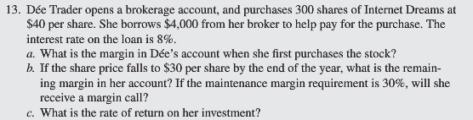

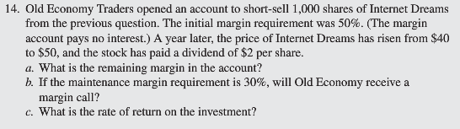

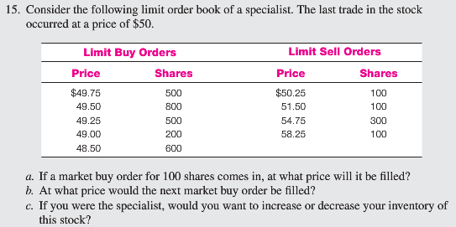

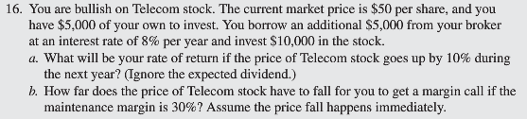

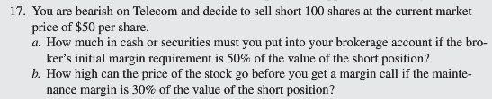

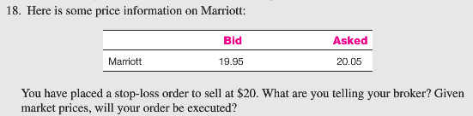

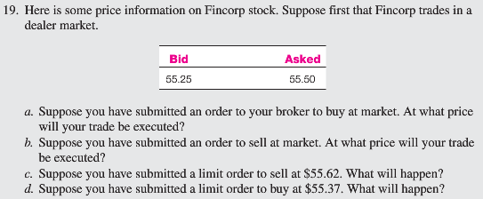

Extra Questions:

- Consider the following limit order book of a specialist. The last trade in the stock occurred at a price of $40. If a market buy order for 100 shares comes in, at what price will it be filled?

- Assume you purchased 500 shares of XYZ common stock on margin at $40 per share from your broker. If the initial margin is 60%, the amount you borrowed from the broker is _________.

- You sold short 300 shares of common stock at $30 per share. The initial margin is 50%. You must put up _________.
- You short-sell 200 shares of Tuckerton Trading Co., now selling for $50 per share. What is your maximum possible loss?

- You short-sell 200 shares of Tuckerton Trading Co., now selling for $50 per share. What is your maximum possible gain ignoring transactions cost?

- You short-sell 200 shares of Rock Creek Fly Fishing Co., now selling for $50 per share. If you wish to limit your loss to $2,500, you should place a stop-buy order at ____.

- You purchased 200 shares of ABC common stock on margin at $50 per share. Assume the initial margin is 50% and the maintenance margin is 30%. You will get a margin call if the stock drops below ________. (Assume the stock pays no dividends and ignore interest on the margin loan.)

- You purchased 250 shares of common stock on margin for $25 per share. The initial margin is 65% and the stock pays no dividend. Your rate of return would be __________ if you sell the stock at $32 per share. Ignore interest on margin.

- The commission structure on a stock purchase is $20 plus $0.02 per share. If you purchase 4 round lots of a stock selling for $56, what is your commission?

- The commission structure on a stock purchase is $50 plus $0.03 per share. If you purchase 600 shares of a stock selling for $65, what is your commission?

- You sell short 200 shares of Doggie Treats Inc. which are currently selling at $25 per share. You post the 50% margin required on the short sale. If your broker requires a 30% maintenance margin, at what stock price will you get a margin call? (You earn no interest on the funds in your margin account and the firm does not pay any

