Chapter 5 Exercises

- Barr Company makes steel and titanium handle bars for bicycles. It requires approximately 1 hour of labor to make one handle bar of either type. During the most recent accounting period, Barr Company made 7,000 steel bars and 3,000 titanium bars. Setup costs amounted to SR.42,000. One batch of each type of bar was run each month. If a single company-wide overhead rate based on direct labor hours is used to allocate overhead costs to the two products, the amount of setup cost assigned to the steel bars will be:

- Kyoto Company allocates overhead on the basis of direct labor hours. It allocates overhead costs of SR.4,000 to two different jobs as follows:
Job 1: (10 hours) = SR.2,000; Job 2: (10 hours) = SR.2,000
The production process for Job 1 was then automated. Now Job 1 requires only two hours of direct labor but four hours of mechanical processing. As a result, total overhead increased to SR.6,000. How much overhead cost will be assigned to Job 2 after automation?

- Brannock Company makes steel and titanium handle bars for bicycles. It requires approximately 1 hour of labor to make one handle bar of either type. During the most recent accounting period, the company made 8,000 steel bars and 2,000 titanium bars. Setup costs amounted to SR.48,000 for the 24 batches (i.e., 12 of each type) of bars produced during the period. If activity-based costing is used to allocate overhead costs to the two products, the amount of setup cost assigned to the titanium bars will be:

- Scott Tools produces a variety of scissors and other cutting instruments at its Statesboro manufacturing plant. The plant is highly automated and uses an activity-based costing system to allocate overhead costs to its various product lines. The company expects to produce 24,000 total units during the current period. The costs and cost drivers associated with four activity cost pools are given below:
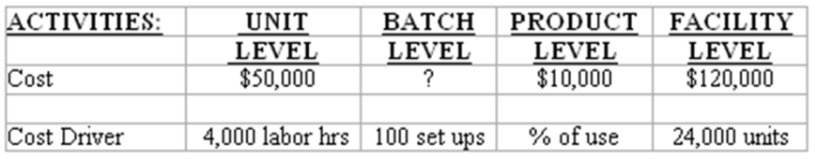
Production of 1,000 units of a pipe-cutting tool required 400 labor hours, 12 setups, and consumed 30% of the product sustaining activities and resulted in an overhead allocation of SR.15,400. What amount of batch-level overhead costs was expected during the period?

- The Ted Company is considering eliminating the following product line:
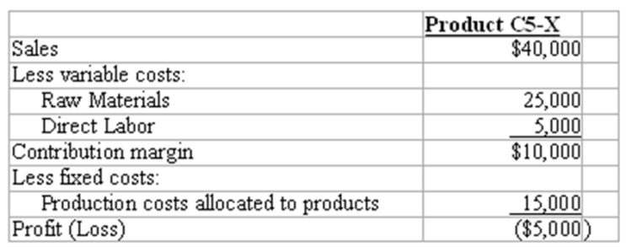
What amount of cost is avoidable if Ted outsources production of this product?

- Franklin Manufacturing manufactures two models of windows, bay windows and casement windows. Franklin uses an activity based costing system. The following information about the activities used to product the company's products has been provided.
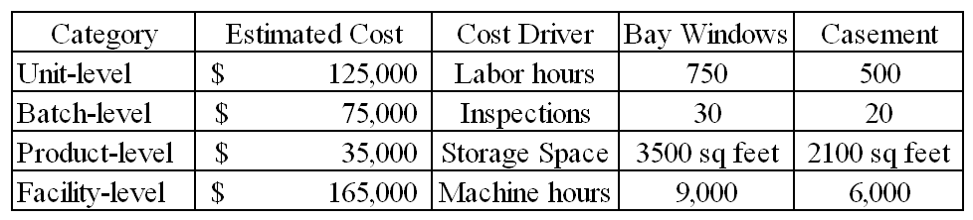
  - The amount of batch-level cost that should be allocated to the casement windows equals:

  - The amount of product-level cost that should be allocated to the bay windows equals
- Office Best Products produces a variety of office products including two models (standard and deluxe) of a hand-held stapler. A number of the company's activity-related costs are described in the following table:
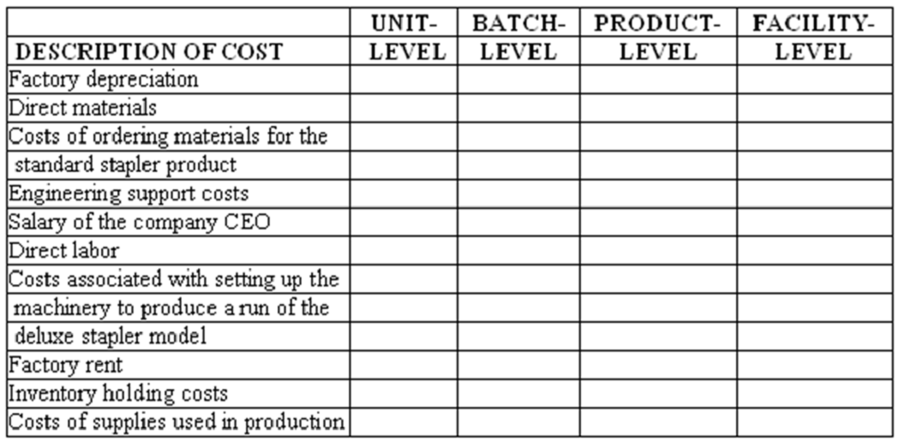
Required: Classify each of the above costs into unit, batch, product, or facility-level cost pools.

- Yamamoto Company produces two types of computer speakers. The Prestige line is made to provide excellent sound for the most demanding applications. The Standard line is geared toward workplace use and delivers average performance. During its most recent accounting period, the company incurred SR.100,000 of inspection costs. Its production activities were classified into four cost centers, unit-level, batch-level, product-level, and facility-level. The following cost and cost driver information is provided for the unit-level and batch-level cost centers:
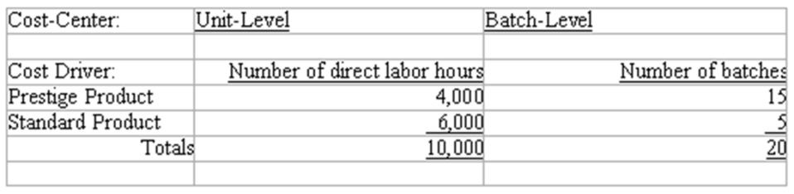
Required
1) Allocate the inspection cost between the two products assuming the inspection cost is driven by
a) Only unit-level activities;

b) Only batch-level activities.

2) How should managers of the company determine which allocation is more appropriate?

- Roadster Tires produces a variety of auto and truck tires at its Dayton manufacturing plant. The plant is highly automated and uses an activity-based costing system to allocate overhead costs to its various product lines. The costs and cost drivers associated with four activity cost pools are given below:
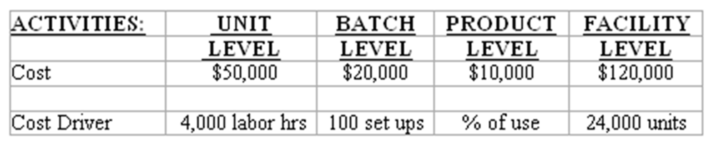
Production of 1,000 units of a small tractor tire required 400 labor hours, 2 setups, and consumed 30% of the product sustaining activities.
Required:
1) Instead of using ABC, suppose the company had used labor hours as a company-wide allocation base. How much total overhead would have been allocated to the tractor tire?

2) How much total overhead costs will be allocated to the tire under activity-based costing?

3) The tire is priced on a cost plus basis. What price will be quoted if the product is priced at 25% above cost? Compute the price under both the direct labor hours approach and under activity-based costing. The direct manufacturing costs consist of direct material of SR.20 and direct labor of SR.30.

4) What implications does ABC have on a company that bids on contracts using a cost plus basis?

