**Jubail University College**



**Department of Business Administration**

**COURSE SYLLABUS - SEMESTER 332**

|  |  |  |  |  |  |  |  |
| --- | --- | --- | --- | --- | --- | --- | --- |
| **Course Code** | **BUS 224** | | | | | | |
| **Course Title** | **Cost Accounting** | | | | | | |
| **Instructor** | **Ms. Zakiya Abdul Samad** | | | | | | |
| **Office Location** | Room 423 | | | | | | |
| **Office Hours** | **Day** | | | **Period** | | | |
| Saturday | | | **-** | | | |
| Sunday | | | **3** | | | |
| Monday | | | **7** | | | |
| Tuesday | | | **1,2,3,7,8** | | | |
| Wednesday | | | **4,5** | | | |
| **Office Phone** | 03-3459000 Extension: 3670 | | | | | | |
| **Email** | [samadz@ucj.edu.sa](mailto:samadz@ucj.edu.sa) | | **Website:** | | | [www.zakiyas.weebly.com](http://www.zakiyas.weebly.com) | |
| **Section** | | | | | **201** | | **202** |
| **Class hours** | | Saturday | | | **4,5** | | **-** |
| Sunday | | | **-** | | **4,5** |
| Monday | | | **3** | | **6** |
| Tuesday | | | **-** | | **-** |
| Wednesday | | | **-** | | **-** |
| **Prerequisites** | | **Accounting 2 [BUS 222]** | | | | | |
| **Course Rationale** | | One of the branches of Accounting, Cost Accounting deals with finding, deciding and analyzing the cost aspect of the business. It forms a decision making tool for the management to take all types of decision in production, Operation, Financing, Staffing and other functional area of management which needs to consider the cost.  This course deals in the theoretical understanding of the concepts and logical application of cost accounting methods in business decisions. Also the students should appreciate and enjoy this course as an independent subject having its own body of knowledge. | | | | | |
| **Course Objectives** | | Upon the successful completion of this course, the student should be able to:  • Identify and use cost accounting terms as they relate to business situations.  • Use the different cost accounting systems as tools for managerial planning and control.  • Apply the fundamental principles of cost accounting to solve problems.  • Evaluate the usefulness of cost accounting information as tools for making various decisions.  • Classify different costs as used for different purposes in business environment. | | | | | |
| **Methods of Instruction** | | Lecture and Presentation, Industrial Visits and Student Individual and Team Projects. | | | | | |
| **Required Textbook** | | **Cost Accounting : A Managerial Emphasis**; Horngren, Datar & Foster; 14th Edition, 2010; Prentice Hall; ISBN 9780273753872 | | | | | |
| **Proposed Websites** | | 1. [www.zakiyas.weebly.com](http://www.zakiyas.weebly.com) 2. [www.pearsonhighered.com](http://www.pearsonhighered.com) | | | | | |
| **Grading Scheme** | | Your final grade will be derived from the weekly assignments and a total of two exams.   Any exam not taken as scheduled will result in a zero.  All assignments submitted after the due date will be subject to a 10-point penalty.  Computation of the final grade will be as follows:  Quizzes 20%  Team Presentation 10%  Individual Project 10%  Midterm Examination 20%  Final Examination 40%  Total 100% | | | | | |

|  |  |  |  |
| --- | --- | --- | --- |
| **Jubail University College Grading Scale** | | | |
| **Total Points** | **Letter Grade** | **Percentage** | **Grade Point** |
|  | A+ | 95-100% | 4.0 |
|  | A | 90-<95% | 3.75 |
|  | B+ | 85-<90% | 3.5 |
|  | B | 80-<85% | 3.0 |
|  | C+ | 75-<80% | 2.5 |
|  | C | 70-<75% | 2.0 |
|  | D+ | 65-<70% | 1.5 |
|  | D | 60-<65% | 1.0 |
|  | F | 0-<60% | 0.0 |
|  | W | Withdrawal | N/A |
|  | WP | Withdrawal while Pass | N/A |
|  | WF | Withdrawal while Fail | 0.0 |
|  | DN | Denial | 0.0 |
|  | I | Incomplete | N/A |
|  | P | Pass | N/A |

|  |  |  |  |
| --- | --- | --- | --- |
| **Course Outline** | | | |
| **Week No.** | **Text Chapter** | **Topic** | **Focus** |
| 1 & 2 | 1 | The Accountant’s Role in the Organization  . | Introduction to the course, Management Accounting, Financial Accounting and Cost Accounting, Value chain analysis, Supply chain analysis, key success factors, cost benefit approach, line and staff relationship, professional Ethics |
| 3 | 2 | An introduction to Cost Terms and Purposes | Costs and Cost terminology, Direct cost Indirect cost, Variable cost and Fixed cost, Cost Drivers, Relevant Range, Total cost and Unit cost, Inventorial cost, Period cost, Prime Cost, Conversion cost, overtime premium and idle costs. |
| 4 | 3 | Cost – Volume – Profit Analysis | Essentials, Equation Method, Contribution Margin Method, Graph method, CVP Assumptions, Breakeven point and Target income, Operating leverage, Contribution Margin Vs. Gross Margin |
| **QUIZ 1 (10%)** | | | |
| 5 | 4 | Job Costing | Job costing, Actual Costing and Normal costing |
| 6 & 7 | 5 | Activity – Based Costing and Activity – Based Management. | Broad Averaging, Under costing and Over costing, Product cost cross Subsidization, Activity Based Costing System and Department Costing systems, Implementing ABC |
| **MID TERM EXAMINATION (20%)** | | | |
| 9 & 10 | 9 | Inventory Costing and Capacity Analysis | Variable Costing and Absorption Costing, Throughput Costing. |
| 11 &12 | 16 | Cost Allocation: Joint Products and Byproducts | Joint Costs, approaches to allocating Joint Costs, Sales Value at split off method, physical measure method, Net Realizable Value (NRV) method, Not allocating joint cost, Accounting for byproducts, production method, sales method |
| **QUIZ 2 (10%)** | | | |
| 13 & 14 | 17 | Process Costing | Calculation of product cost with or without ending inventory, Weighted Average method, FIFO method. Standard costing method of process costing. |
| 15 | 20 | Inventory Management, Just in Time and Simplified Costing Method | Inventory management in Retail Organization, EOQ Decision models, JIT in Service Industries, ERP systems, Simplified Normal costing and Standard Costing, Lean Accounting. |
| 16 | **Review and Revision** | | |
| 17 | **FINAL EXAMINATION (40%)** | | |

|  |  |
| --- | --- |
| **Jubail University College Policies** | |
| **Attendance** | 1. Attending at punctual time: Present otherwise the student is absent.  2. Late attendance 0 − < 5 minutes: is late  3. Late ≥ 5 minutes: is absent  Notes:   1. Every 3 late are counted as 1 absent 2. Every × total semester contact hours + 1 is DN |
| **Grading** | 1. Quality point: is the result of multiplying the credit hours by the grading points. 2. Semester GPA: is the result of dividing total quality points achieved in all courses at that semester by total graded credit hours of all courses in that semester. 3. Cumulative GPA in a semester: is the sum of total quality points achieved in all courses up to that semester divided by the total credit hours graded for all courses up to that semester |
| **Plagiarism & Cheating** | 1. Cheating is a serious offence and will be punished by the JUC.  2. Talking, looking at your colleagues’ exam papers or any other suspicious act is considered cheating during exam.  3. Student will fail the subject if caught cheating. |

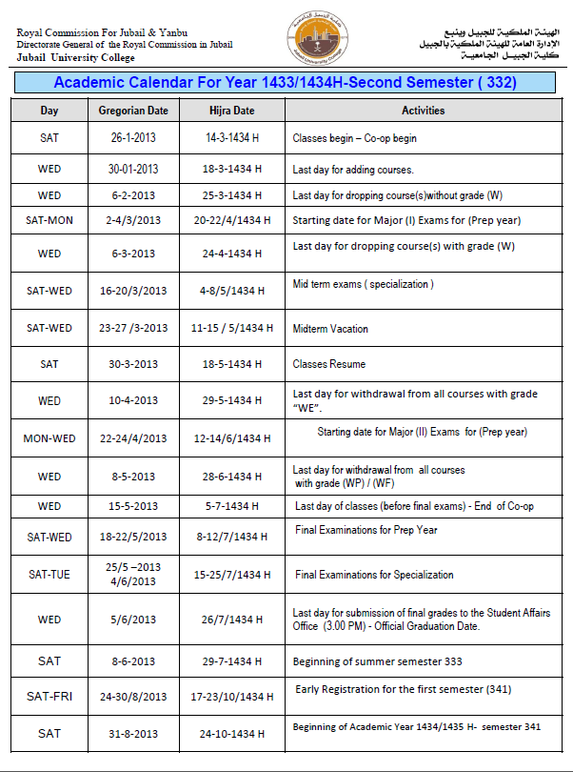

**Let’s Have a Great Semester!!**