

**Jubail University College**

**Department of Business Administration**

**COURSE SYLLABUS - SEMESTER 322**

[Provided to students in soft copy through my website]

|  |  |  |  |  |
| --- | --- | --- | --- | --- |
| **Course Code & Number** | **BUS 428** | | | |
| **Course Title**  **Skill** | **Managerial Accounting** | | | |
| **Instructor** | **Ms. Zakiya Abdul Samad** | | | |
| **Office Location** | **Room**  **423** | | | |
| **Office Hours** | **Day** | **Period** | | |
| **Saturday** | **2,3,4,5,8** | | |
| **Sunday** | **3** | | |
| **Monday** | **3** | | |
| **Tuesday** | **4** | | |
| **Wednesday** | **1,2,3,4,5** | | |
| **Instructor’s Office Phone** | **03-3459000 Extension: 3663** | | | |
| **Instructor’s Email** | [samadz@ucj.edu.sa](mailto:samadz@ucj.edu.sa) | | **Instructor’s Website** | <http://zakiyas.weebly.com/> |
| **Section** | **201** | | | |
| **Class hours** | **Day** | **Period** | | |
| **Saturday** | - | | |
| **Sunday** | **4,5** | | |
| **Monday** | - | | |
| **Tuesday** | **5** | | |
| **Wednesday** | - | | |
| **Prerequisites** | **BUS 222 Accounting 2** | | | |
|  | | | | |
| **Course Rationale and Aim** | The course aims at developing knowledge and skills of the students in the application of management accounting techniques to quantitative and qualitative information for planning, decision-making, performance evaluation, and control | | | |
| **Course Objectives** | On successful completion of this course the students should be able to:   1. Explain and apply managerial accounting techniques. 2. Choose and apply proper decision-making techniques in business decisions and promote efficient and effective use of scarce business resources. 3. Appreciate the risks and uncertainty inherent in business and controlling those risks. 4. Identify and apply appropriate budgeting techniques and methods for planning and control 5. Use standard costing systems to measure and control business performance and to identify remedial action 6. Assess the performance of a business from both a financial and non-financial viewpoint, appreciating the problems of controlling businesses and the importance of allowing for external aspects.  NEEDS AND RESOURCESTo successfully complete this course, you must  * Have a working knowledge of the basic elements of Accounting learnt in Accounting 1 and 2. * Know the basic mathematical calculations, use of simple calculator and an understanding of computer use. * Willingness to relate the conceptual knowledge builds in the class with its application in the real world. * Dedicated hard work, continuous practice and discussion with colleagues and lecturer. | | | |
| **Methods of Instruction** | Class Presentation, Lecture, Student Participation and Practical Involvement, Group Work & Assignments | | | |
| **Required Textbook** | Fundamental Managerial Accounting Concepts, Thomas P. Edmonds  Bor-Yi Tsay, Philip R. Olds – 6th Edition-ISBN 13: 9780071220729 | | | |
| **Proposed Websites** | 1. <http://highered.mcgraw-hill.com/sites/0078110890/student_view0/index.html> 2. <http://www.learnerstv.com/Free-Management-Video-lectures-ltv638-Page1.htm> 3. <http://www.learnerstv.com/Free-Management-Video-lectures-ltv034-Page1.htm> | | | |
| **Grading Scheme** | Your final grade will be derived from the weekly assignments and a total of two exams.   Any exam not taken as scheduled will result in a zero.  All assignments submitted after the due date will be subject to a 10-point penalty.  Computation of the final grade will be as follows:  Quizzes 20%  Assignments 20%  Midterm Examination 20%  Final Examination 40%  Total 100%  For the Assignment grades would be based on the practical work assigned and discussed in class. | | | |

|  |  |  |  |
| --- | --- | --- | --- |
| **Jubail University College Grading Scale** | | | |
| **Total Points** | **Letter Grade** | **Percentage** | **Grade Point** |
|  | A+ | 90-100% | 4.0 |
|  | A | 90-<95% | 3.75 |
|  | B+ | 85-<90% | 3.5 |
|  | B | 80-<85% | 3.0 |
|  | C+ | 75-<80% | 2.5 |
|  | C | 70-<75% | 2.0 |
|  | D+ | 65-<70% | 1.5 |
|  | D | 60-<65% | 1.0 |
|  | F | 0-<60% | 0.0 |
|  | W | Withdrawal | N/A |
|  | WP | Withdrawal while Pass | N/A |
|  | WF | Withdrawal while Fail | 0.0 |
|  | DN | Denial | 0.0 |
|  | I | Incomplete | N/A |
|  | P | Pass | N/A |

|  |  |  |  |
| --- | --- | --- | --- |
| **Course Outline** | | | |
| **Week** | **Topics & Activities** | **Chapter** | **Notes** |
| 1 & 2 | Management Accounting & Corporate Governance | 1 | Managerial and Financial Accounting, Product Costing in Manufacturing, service and Merchandising Companies. |
| 3 | Analysis of Cost volume & pricing to increase profitability | 3 | Break-even point, Cost Volume Profit (CVP) Analysis, Sensitivity Analysis and Margin of safety |
| 4 | Cost Accumulation, Tracing & Allocation | 4 | Cost objects and cost drivers, direct and indirect cost and Cost Allocation. |
| **Quiz 1 (10%)** | | | |
| 5 and 6 | Cost Management in Automated Business environment: ABC, ABM and TQM | 5 | Activity Based Costing, Under costing, over costing, Downstream costs and upstream costs and TQM |
| 7 & 8 | Planning for Profit &Cost Control | 7 | The Planning Process, Three level of planning for business activity, Budgeting Practice |
| **Mid Term (20%)** | | | |
| 9 & 10 | Performance Evaluation | 8 | Different types of Variances: Sales and Variable Cost Variance, Flexible Budget Variances, Fixed Cost Variances. Standard Cost Systems, Selling General and Administrative Cost Variances. |
| 10 &11 | Responsibility Accounting | 9 | Decentralization, Responsibility centers and Reports, Management by Exception, Return on Investments, Residual Income. |
| **Quiz 2 (10%)** | | | |
| 12 & 13 | Planning for Capital Investment | 10 | Time Value of Money, Capital Investment Decisions, Present Value And Future Cash Flows, Return of investment opportunity, Investment alternatives, NPV, IRR, Payback Period |
| 14 & 15 | Financial Statement Analysis | 13 | Horizontal and vertical analysis, ratio analysis, Assessing company’s liquidity, solvency and effectiveness |
| 16 | **Revision** | | |
| 17& 18 | **Final Examination (40%)** | | |

|  |  |
| --- | --- |
| **Jubail University College Policies** | |
| **Attendance** | 1. Attending at punctual time: Present otherwise the student is absent.  2. Late attendance 0 − < 5 minutes: is late  3. Late ≥ 5 minutes: is absent  Notes:   1. Every 3 late are counted as 1 absent 2. Every × total semester contact hours + 1 is DN |
| **Grading** | 1. Quality point: is the result of multiplying the credit hours by the grading points. 2. Semester GPA: is the result of dividing total quality points achieved in all courses at that semester by total graded credit hours of all courses in that semester. 3. Cumulative GPA in a semester: is the sum of total quality points achieved in all courses up to that semester divided by the total credit hours graded for all courses up to that semester |
| **Plagiarism & Cheating** | 1. Cheating is a serious offence and will be punished by the JUC. 2. Talking, looking at your colleagues’ exam papers or any other suspicious act is considered cheating during exam. 3. Student will fail the subject if caught cheating. |

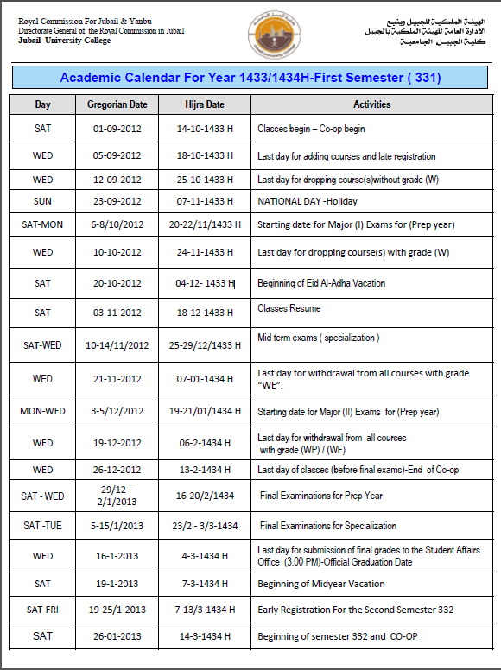

**Let’s Have a Great Semester!!**